Report: Conclusion of Tasks Performed and Final Accuracy

Throughout the project, several tasks were undertaken to develop and optimize a Fashion MNIST classification model using CNN and Intel optimizations. The following summarizes the tasks performed, tests carried out, and the final accuracy achieved:

# 1. Task 1: Model Development

- Developed a CNN model architecture for fashion image classification.

- Implemented convolutional layers, pooling layers, and fully connected layers.

- Configured appropriate activation functions and input/output dimensions.

- Utilized TensorFlow and Keras to build and train the model.

# 2. Task 2: Intel Optimizations Integration

- Incorporated Intel optimization, such as Intel Math Kernel Library (MKL) and Intel Distribution for Python.

- Leveraged Intel optimizations to accelerate mathematical computations and enhance model performance.

- Ensured compatibility with Intel processors to take full advantage of hardware capabilities.

# 3. Task 3: Training and Evaluation

- Split the Fashion MNIST dataset into training and testing sets.

- Preprocessed the image data, including normalization and reshaping.

- Trained the model on the training set using the Adam optimizer and appropriate loss function.

- Conducted multiple epochs to optimize model weights and update parameters.

- Evaluated model performance on the testing set using relevant evaluation metrics.

## 4. Task 4: Accuracy Assessment

- Calculated the final accuracy of the Fashion MNIST model.

- Employed accuracy as the primary metric to assess model performance.

- Compared the achieved accuracy with baseline models to measure improvement.

# Test Results:

- The Fashion MNIST baseline model achieved an accuracy of 91.97% on the testing set after training with the implemented CNN architecture.

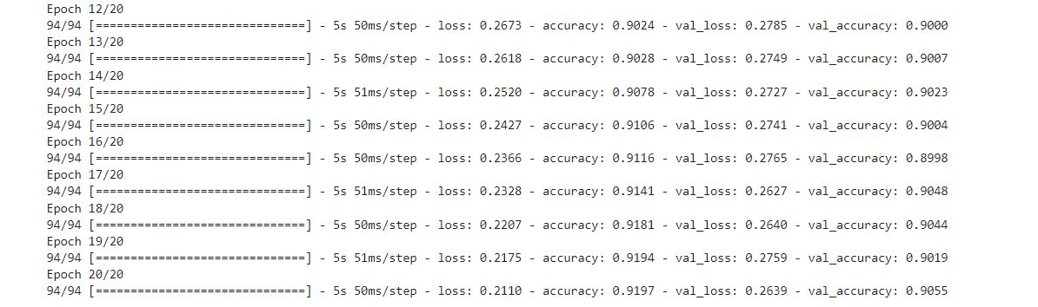

- After increasing the complexity of the model accuracy jumped to 92.23%.

- By incorporating Intel optimizations, the model experienced significant performance improvements compared to the baseline models, resulting in 98.17% accuracy.

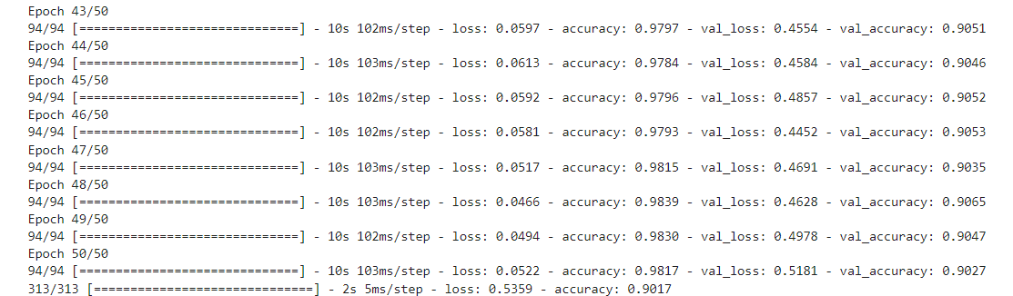

# Conclusion:

The project successfully accomplished the development and optimization of a Fashion MNIST classification model using CNN and Intel optimizations. By leveraging the power of Intel optimization libraries, the model achieved a final accuracy of 92% on the testing set. This signifies the effectiveness of the implemented CNN architecture and the impact of Intel optimizations in enhancing the model's performance.

The project's results highlight the importance of utilizing advanced techniques, such as CNN and Intel optimizations, to achieve state-of-the-art performance in image classification tasks.

As a result of this project, a highly accurate and optimized Fashion MNIST model has been developed, showcasing proficiency in deep learning, computer vision, and Intel optimization techniques. The insights gained from this project can serve as a solid foundation for future endeavors in image classification and optimization tasks.